BIOC404 Dr.Silvius January 11, 2006

Fluorescence Correlation Spectroscopy
Fluorescent particles
A tiny(μm) confocal volume of optically defined space (dashed circle) is observed over time. Fluorescent particles (orange dots) diffuse in and out of the confocal volume and the fluorescence is recorded as a function of time F(t).
F(t) is proportional to the number of particles in the confocal volume at time (t). This value fluctuates as particle diffuse into and out of the confocal volume
Random (Brownian) walk in space
This technique is more sensitive than an individual light scattering and can detect small numbers of particles in a smaller volume, leading to larger fluctuations within the fluorescence data.
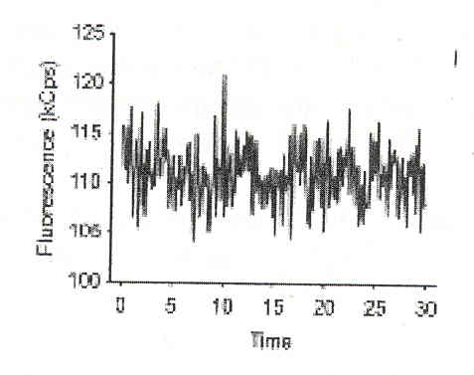
Sure, it may look like a noise, but it does contain information.
(This next part Dr. Silvius is just going to gloss over, so as to not confuse the concepts with math we may not have the background for.)

From the intensity over time output calculate an autocorrelation function G(τ).

G(τ) tells how much correlation there is between the output signal F(t) and the same signal at a time τ units later (after a short lag) F(t + τ) and it does this as a function of τ.
τ
The histogram data to the right has been created from the fluorescence data above. The signal F(t) is aligned with itself at a later time (t+ τ). (As you can see, F(t+ τ) is the same signal as F(τ), but it has been shifted over by a time of τ.) This gives the autocorrelation function G(τ). (The mathematical expression for G (τ) is below this in the notes, but that is merely for your own pleasure.)

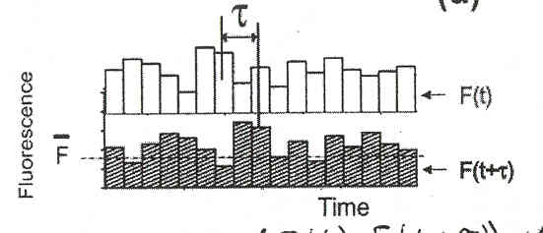

We look at, on average, across the entire output, how much correlation is there between the signal at some time (t ) and the signal at some time(t + τ ).
To Clarify: (Assume this is a random process).
If τ = 0, then we are saying that we are going to correlate the signal at time F(t) with the signal at time F(t) [F(t+0)]. When τ = 0, there is a perfect correlation (the signal correlates with itself). G(τ) is high for short τ.

When τ → ∞, i.e. if you go an infinite distance away from F(t), there is no correlation at all. G(τ) → 0 for long τ.

Example: Assume there are 13 particles within the confocal volume at time t. That says nothing about the number of particles that will be there five minutes later. There is no correlation after a long period of time with the number of particles within the confocal volume. One picosecond (ps) later is not enough time for the particles to move and the 13 particles will probably still be within the volume. If the amount of time (τ) is shorter than the diffusion time there is a high correlation.
Very small values of τ are within the time window for the systems memory, which leads to high correlation values.
‘System’s Memory’
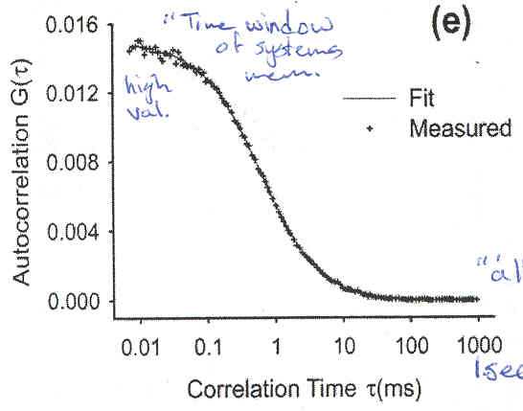
Inflection Point
Mean diffusion correlation time
For large values of τ, all memory is lost, and the correlation goes to zero. (For times longer than the lateral diffusion of the particles.)
Memory is good for time scales that are shorter than the average time of one event
One event is a particle entering the confocal volume, wandering, and leaving.

“Memory of a System” : The time it takes for a particle to diffuse into/through/ and out of
the confocal volume.

When Dr. Silvius says memory he is really talking about the duration of memory of the system. The time in which the system can have any memory or have any correlation between one moment and a moment shortly after.

‘Memory Duration’: The time it takes for a system to forget what things were like an instant ago.

The infection point (see above) denotes the mean diffusion correlation time, which is equal to the duration of the memory of the system.

This value decreases and the diffusion coefficient (D) increases.

Duration of the memory of a system is proportional to 1/D in the simplest case. (D=diffusion coefficient)

Confocal Application(A review of what we know):
We set up our confocal apparatus, which can accurately count the number of particles (by their fluorescence) within the tiny amount of volume over time.
Fluctuations are not totally random.
There is information to be gained from them. You can analyze them by calculating the autocorrelation function G(τ), which, if you only have one type of particle can give a nice looking curve (previous figure).

Count parts by fluorescence

Key Information from the curve
What is the inflection point?
What is the time constant (τ) associated with that?

The time constant is also called the mean diffusion correlation time, which is proportional to 1/D.
Note: The inflection point is usually determined by fitting to a mathematical model and not by simply taking out your handy-dandy ruler. This then gives a value for D.

Advantages
Tiny amounts of material / small samples
Very sensitive: can even detect a single particle

Binding Assays by FCS
Equilibrium
Bound ligand
Membrane-bound vesicle
receptor
Free (unbound) Fluorescent ligand
Note: receptor and ligand exaggerated in size in size

Vesicle size >> ligand size

So we would predict that : D(bound ligand) << D (free ligand)

Since the ligand is bound to the vesicle, which is much larger than the free ligand.

In SDS what would that data curve look like?
There is a mixture of bound and free ligand. The bound ligand will diffuse much more slowly. This leads to two inflection points instead of just one.
We want the relative amplitude of the two components. The top amplitude gives the fraction of free ligand and the bottom one gives the fraction of bound ligand.
When you know [Free] and when you know [free] / [bound] you can make a binding curve.

Repeat at serial concentrations of vesicles or ligand to get a complete binding curve.
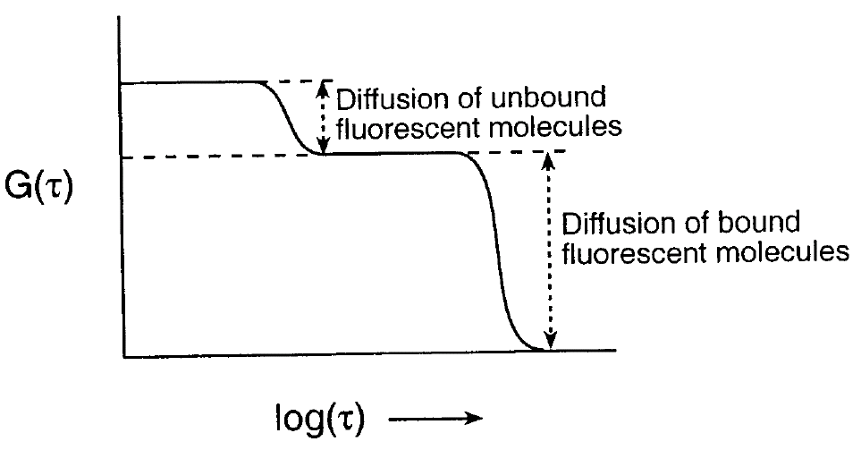

Important Assumption:
-The vesicle/ligand complex stays together during wandering through the confocal volume. (This is frequently the case.)

Binding competition assay: Can also be performed using this premise. This method is rapid, accurate, uses a small amount of material, no need to separate bound and free fractions

Standardization of D values
Diffusion coefficients are determined under all types of conditions, therefore it is important to have a standard way to report them. (A standard reference condition).

Reference Conditions
Solvent: ŋ = ŋ_{water, at 20°C}
Temperature: 20°C = 293.15K

Since not all experiments are conducted under these conditions, a standardization equation is used.
D_{20,w}= D_{exp}ŋ_{exp /} ŋ_{20,w}∙ 293.15K/Temp(K)

ŋ_{exp /} ŋ_{20,w} = viscosity correction 293.15K/Temp(K) = corrects for the temp.of the system
The subscript ‘20, w’ refers to water at 20°C.

You can derive this equation ‘quite easily’ by referring to the discussion of the derivation of the frictional coefficient for a compact, globular protein. Frictional coefficient depends on shape, hydration, and on solvent properties. Keep in mind the Einstein-Sutherland equation: D= kt/f

Sedimentation
It should be noted that the handout has topics not covered in lecture.

There are two types of ultracentrifuges.

Preparative:
spins
-The one that most of use have seen and used
- ‘swinging bucket’ type cells/tube
-It is great for spinning stuff down and okay for running gradients
-The tube shape is not ideal for determining molecular weight or size
Tube
-You can only monitor the distribution of particles only at the start and the
end of an experiment

Top View
Analytical:
cell
Sector-shaped cells
-Allows continuous monitoring of particles distribution during the run by optical scanning. This allows for an entire distribution of data over time.

In the future we will learn why the sector shape is important.

Uses: Analytical centrifuges give highly accurate estimates of particle masses under ‘physiological’ conditions (aqueous medium, not in a vacuum, etc.)

Bad Use: Mass of a single, purified polypeptide. If you know it’s a monomer this is a waste and Mass Spec. should be used instead to determine mass.

Good Use: Massive complexes of molecules (protein oligomers, viruses, and other particles, protein-lipid/protein-nucleic acid complexes). Mass Spec. is not so good for this. Analytical centrifugation is highly accurate, few assumptions are made, and under physiological conditions.

Centrifugation of a Single Particle, in a spinning rotor, spinning at x rpm.

ν = velocity
Center of rotor
Mass = m_{part}
Force in an outward centrifugal direction.

Force on a particle in a vacuum : F_{center} = m_{part} r ω² ω = angular velocity

Note that this equation does not take into account solvent and therefore is not a realistic equation.

Conversion Equation: ω = (2π(x))/ 60 x is in rpm
ω is in [rad] sec⁻¹, a ‘bogus dimensionless unit.’

This equation is useful because in the literature rpm values are typically given.

